Supplier ESG/Sustainability Survey


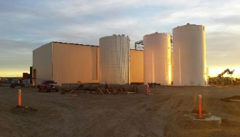

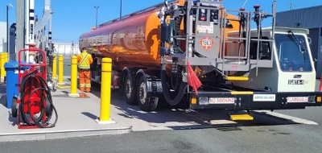

Purpose of This Survey

The Inland Group of Companies comprised of Inland Technologies Canada Inc. (ITC), Inland Technologies International Ltd. (ITI), Quantem Aviation Services LLC (QAS), & Integrated Deicing Services LLC (IDS), is committed to a sustainable business model that ensures a responsible approach to the environment, people, and business ethics. Because sustainability extends throughout our value chain, we expect all our suppliers of goods and services to comply with applicable safety, environmental, and business laws and to operate in an ethical manner. We therefore ask all our vendors, suppliers, and contractors to complete this survey to verify that our partners support our environmental, social, and governance (ESG) objectives, in accordance with our Sustainable Procurement Policy and our Supplier Code of Conduct. Please see our Supplier Code of Conduct on our website under the ESG heading (https://inlandgroup.aero/forms-documents). This is not a prequalification process. We understand that every company will have different sustainability practices appropriate to their size, type of business, location, and other factors.
Thank you in advance for your response, please send completed survey to procurement@inlandgroup.ca . For questions, or assistance, please contact EHS@inlandgroup.ca. We may contact you about your responses.

Your Company and Follow-up Information
Company Legal Name:
Official Company Address:
Company Contact Name:
Email:
Phone:
Company Website:
Date Survey Completed:
What Products or Services Do You Provide To Our Company?

Environmental Sustainability

Please Answer “Yes”, “No” or “Not applicable”. Details can be added at the bottom if needed.
Does your organization comply with all environmental regulations and laws, including holding necessary permits and approvals, applicable to your business?
Have you been convicted of breaking any environmental regulations or laws?
Do you have an environmental policy?
Do you have a written Environmental Management System or Plan?
Do you have any formal environmental goals and/or targets?
Does your organization try to limit your impact on the ecosystem by minimizing your air, land, and water emissions; minimizing material use and waste; and choosing products and chemicals less harmful to the environment?
Please add any details needed to explain your answers above:

Social Sustainability

Please Answer “Yes”, “No” or “Not applicable”. Details can be added at the bottom if needed.
Does your organization comply with all health and safety regulations and laws applicable to your business?
Do you have a health and safety policy?
Do you have a written Safety Management System, safety plan, or equivalent?
Have you been convicted of breaking any health and safety laws or regulations?
Have you had any employee or other fatalities as a result of your business?
Do you provide safety training to your employees?
Do you ensure employees use personal protective equipment when needed to work safely and prevent injury?
Does your organization comply with all labour standards regulations and laws applicable to your business, including work hours, wages, benefits, etc.?
Do you prohibit the use of child labour in your business (younger than 15)?
Do you prohibit the use of forced or compulsory labour?
Do you have a human rights policy to address issues such as discrimination, harassment, and unfair treatment on the bases of ethnicity, gender, religion, and other individual characteristics?
Please add any details needed to explain your answers above:

Governance Sustainability

Please Answer “Yes”, “No” or “Not applicable”. Details can be added at the bottom if needed.
Does your organization comply with all business practice regulations and laws applicable to your business, including those related to competition, corruption, bribery, securities, ethics, and financial affairs?
Have you been convicted of breaking any business practice laws or regulations?
Do you have a business ethics policy, code of conduct, or equivalent?
Are you confident in your ability to safeguard proprietary information about our company that you may have access to as a vendor or contractor for us?
Do you have information technology protections in place to safeguard email, company servers, on-line data, and other systems that could contain information about our company?
Are you aware of any conflict of interest that might exists as a vendor or contractor with us (family relations, business dealings, investment, etc.)?
Please add any details needed to explain your answers above:

Thank You for Completing our Survey!

Non-Discrimination Statement

In our business dealings, including but not limited to matters of employment and procurement, our organization will not discriminate on the basis of any class, status, or grounds protected under any applicable law. Related company policies can be provided on request.

